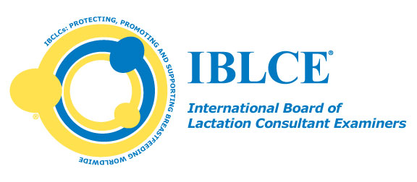

|  |  |  |  |
| --- | --- | --- | --- |
| |  |  |  | | --- | --- | --- | | |  | | --- | | FOR IMMEDIATE RELEASE  Contact: Sara Blair Lake, J.D., CAE  Tel: [703.560.7330](tel:703.560.7330)  Email: [international@iblce.org](mailto:international@iblce.org) | |  | |
| |  |  | | --- | --- | | |  | | --- | | http://img.constantcontact.com/letters/images/1101093164665/S.gif | |  |  | | --- | | **IBCLC Certification Program Reaccredited by NCCA**  ***Marks 26 years of continuous NCCA accreditation*** |  |  | | --- | | The International Board of Lactation Consultation Examiners® (IBLCE®) is pleased to announce that the National Commission for Certifying Agencies (NCCA) of the Institute of Credentialing Excellence (ICE) recently reaccredited IBLCE's International Board Certified Lactation Consultant® (IBCLC®) certification program. The NCCA *Standards for the Accreditation of Certification Programs* are recognized worldwide as the first accreditation standards in the certification industry and the IBCLC program has been continuously accredited by NCCA since 1988.  http://ih.constantcontact.com/fs157/1101909068365/img/299.jpg  IBLCE Chair Tomoko Seo, M.D, IBCLC of Aichi, Japan stated, "This is excellent news for IBLCE and indeed for all IBCLCs. The IBCLC program was one of the very first certification programs to earn the prestigious NCCA accreditation and it is a tremendous accomplishment to hold this accreditation for twenty-six consecutive years."    During the objective third-party review process of NCCA reaccreditation, numerous aspects of the IBCLC certification program are examined and evaluated against the twenty-one rigorous NCCA Standards including:  the structure and governance of IBLCE; the development, administration, validity and scoring of the IBCLC certification examination; the information available to applicants, certificants, and the public; and recertification requirements designed to evaluate continued competence on the part of IBCLCs. Reaccreditation by NCCA demonstrates that IBLCE is committed to self-examination, external periodic review  against recognized certification industry standards and continuous improvement to maintain the quality of the IBCLC certification program. | |  |  |  | | --- | | # # #  IBLCE is the International Board of Lactation Consultant Examiners, establishing the highest standards in lactation and breastfeeding care worldwide and awarding the International Board Certified Lactation Consultant (IBCLC) credential to individuals who meet these standards. [www.iblce.org](http://r20.rs6.net/tn.jsp?f=0016x-5FfHE_MwhWkc2vuAjo5GIU_mHMEB8OFRcOcZSgY5Q6pGQviC8WZrGFj4WIEsiDyywiI8vWMNzz1rdq41InGWkfp1f6Yp0Mt0bHWPtvvrh7nzWdxyAJY0kHiJCuSkWsbzJTEuj4pm_L_IxV5Ohsr2pMVU2Hl5SsbzErwexfCc=&c=R-TEkd-RAIlhdmTufqsoYQ9UDm2X4niDrzk-TPqqV4LPBqYHtM4g1g==&ch=QLGP4dpEPHEc57_zkrOG4DMA63EpkU-RRQmZFzvn6WJOfoi99IrBNA==)  If you would like more information on this topic, or would like to arrange an interview, please contact Sara Blair Lake at [703.560.7330](tel:703.560.7330) or [international@iblce.org](mailto:international@iblce.org) | |
| |  |  | | --- | --- | | |  | | --- | | http://img.constantcontact.com/letters/images/1101093164665/S.gif | |  |  | | --- | | International Board of Lactation Consultant Examiners®                          International Board Certified Lactation Consultant® | |